# authentication.inc

# 

# index.php

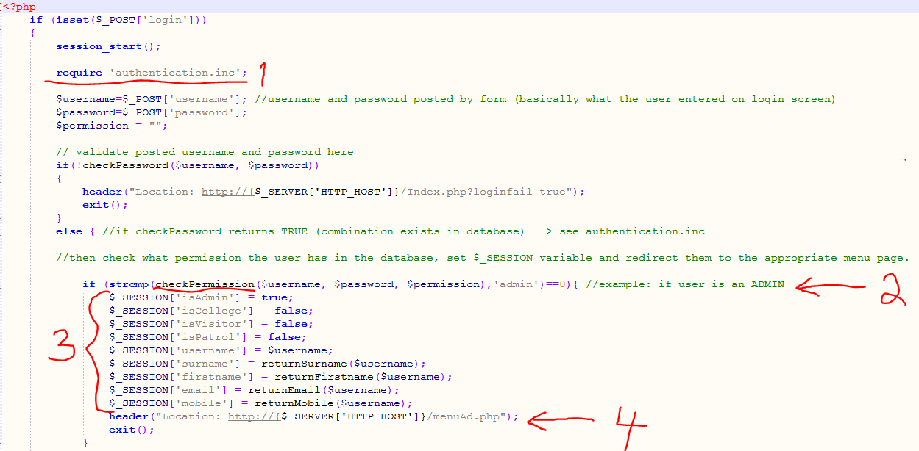

Step 1:

Require authentication.inc file with PHP functions

Step 2:

Run checkPermission() function from required .inc using the user’s username and password

Step 3:

If returned permission is as expected, set $_SESSION variables

Step 4:

Redirected to menu according to permission

# adminPermission.inc

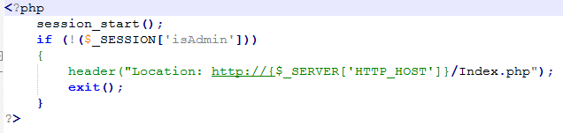

# menuAd.php

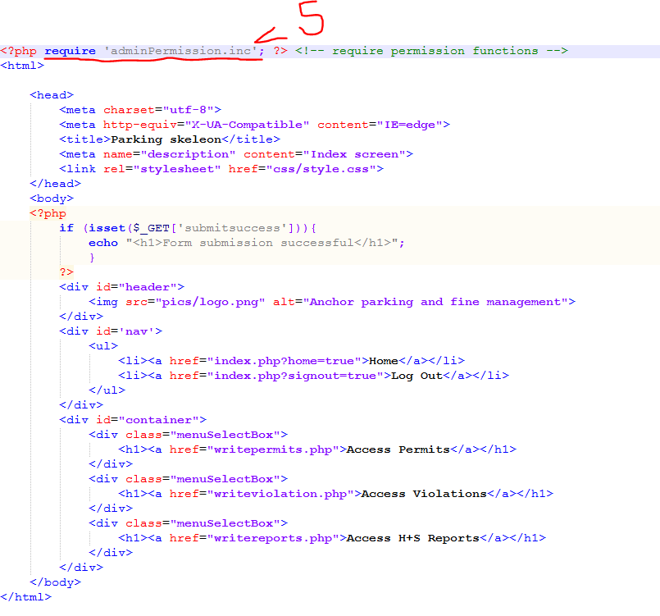

Step 5:

Menu page checks user permission by requiring adminPermission.inc - kicks user from page if they have incorrect permission